CHAPTER V

Why do Aeroplanes Fly?

Introduction

It is truly incredible to see an Airbus A380 (fig. 1) take off. It just doesn’t make any sense that such a heavy thing can be held up on air. But the sums do make sense. The plane weighs 560 tonnes and the wing area is 840 square metres. Hang on, that’s one fifth of the area of a football ground! This is where we get caught out – we don’t often look at the plane from above. The average air pressure needed to hold the plane up is 67 millibar which is not far from the suck of a decent vacuum cleaner. You get this kind of pressure across the wings when going at 200 mph.

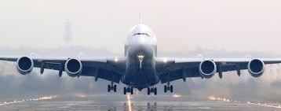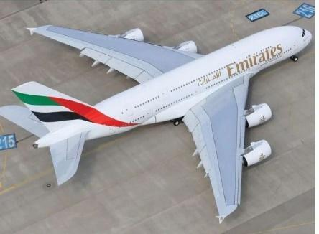

Fig. 1. The Airbus 380. OUP: I DON'T KNOW WHERE THESE IMAGES COME FROM

Getting comfortable with some of the concepts isn’t easy but it’s certainly worthwhile.

Explaining why airplanes fly has been a common undergraduate interview question that has produced a lot of nonsense involving the Bernoulli effect, although it must be said that Wikipedia has recently done a lot to dispel the most obvious misunderstandings. However, it will become apparent that it is not really possible to give a realistic explanation of lift without a good deal of mathematics. This is because most of the lift is generated by vortices emanating from the trailing edge and depends on how sharp this is, rather than on the shape of the entire airfoil.

The simplest flying machine is a paper dart. This can fly for thirty seconds with a starting speed of 3 m/s, which implies a lift to drag ratio of eighty. This is pretty good for a wing consisting of a sheet of paper with no profiling. Figure 2 shows a simple paper sheet, which can represent a wing, or, equivalently, a sail, at an angle to a flow of fluid, with a schematic set of stream-lines [the paper by Holger Babinsky (1) on How do Wings Work? gives a good overview of the role of stream-lines in the lift of an aeroplane].

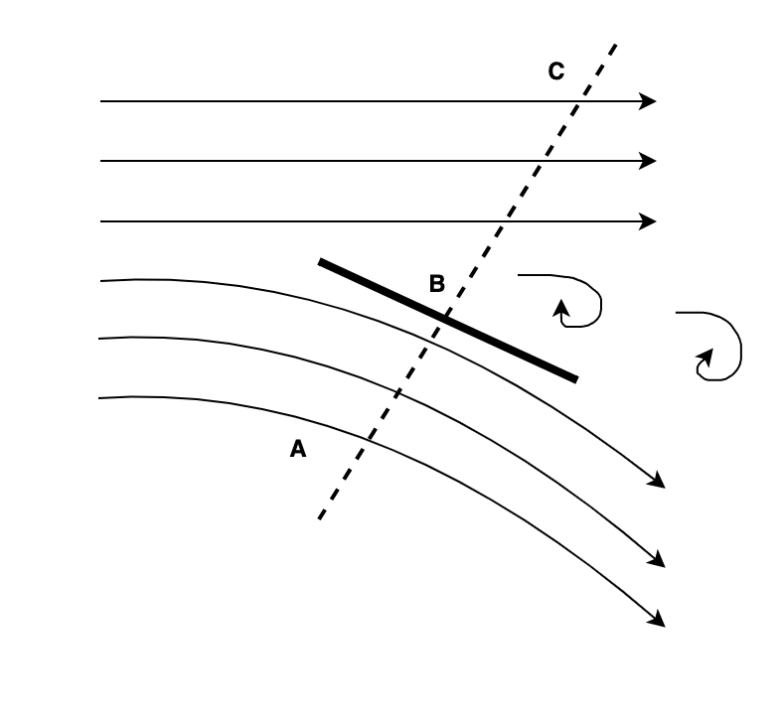 | 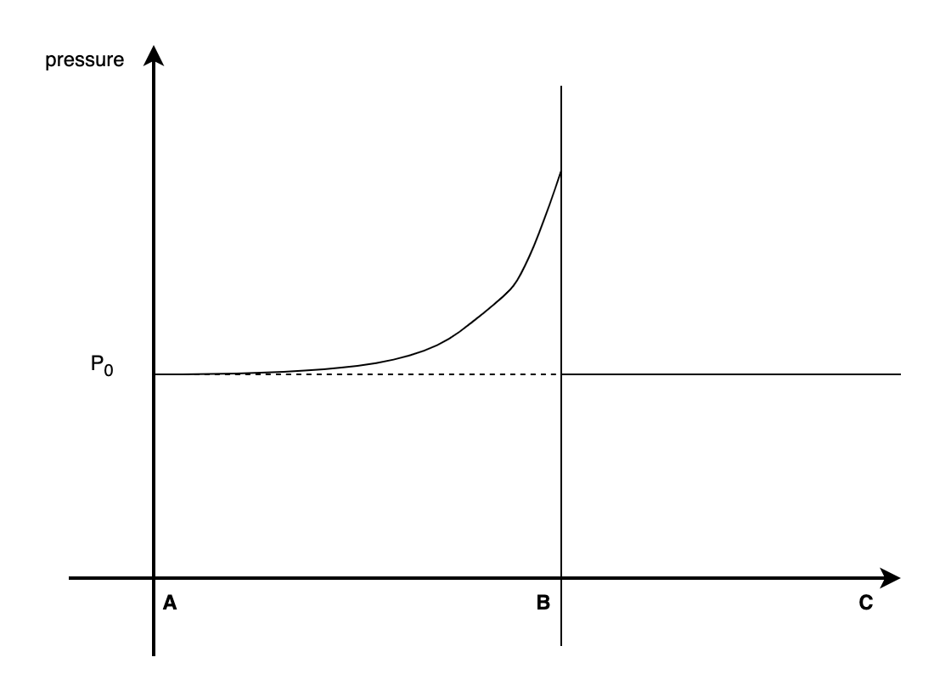
(a) | (b)

Fig. 2. Flow around a flat sheet for the case of zero viscosity. (a) the flow underneath the sheet is forced to curve but the flow above is unaltered. (b) pressure distribution along the dotted line (ABC), showing high pressure under the sheet which generates lift.

We assume zero viscosity, so it is possible that above the sheet the flow just carries straight-on leaving a stationary wake. The fluid must curve away below the sheet, on the other hand, and this is the source of the lift. Whenever streamlines flow in a curve there is a pressure gradient that can be regarded as either due to the centrifugal force or providing the centripetal acceleration. Either point of view is equally valid. The pressure gradient is given by dp/dr = ρv²/r, where ρ is the fluid density, v the velocity and r the radius of curvature. It is clear from fig. 2(b), which shows the pressure along the dotted arrow in fig. 2(a), that the pressure must increase from atmospheric well away from the sheet to a higher value on the sheet itself. On the other side streamlines are parallel so the pressure is atmospheric. There is, therefore, a higher pressure on the bottom surface of the sheet and a corresponding lift force. This force due to the pressure on the sheet must be consistent with the net change of momentum flowing out of a control volume round the sheet (Newton’s second law). It can be seen that there is a net downward flow, hence a corresponding vertical force (Newton’s third law).

Figure 2 shows a flow that is a solution of the fluid equations for zero viscosity, but it is far from being the only one. The first modification is that at the leading edge there is a very large velocity gradient, so that, even with a small viscosity, air is initially sucked out from just behind the leading edge, lowering the pressure. This, in turn, will cause the flow to bend round to fill the gap so that it follows the upper surface of the sheet (usually known as the Coanda Effect). Persuading the flow to follow the sheet all the way, as shown in fig. 3(a), produces a pressure gradient above the sheet, as shown in fig. 3(b). Clearly this will double the discontinuity across the sheet and hence generate more lift.

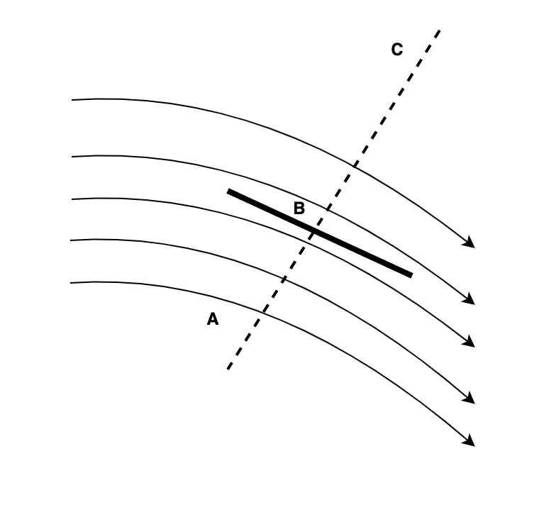 | 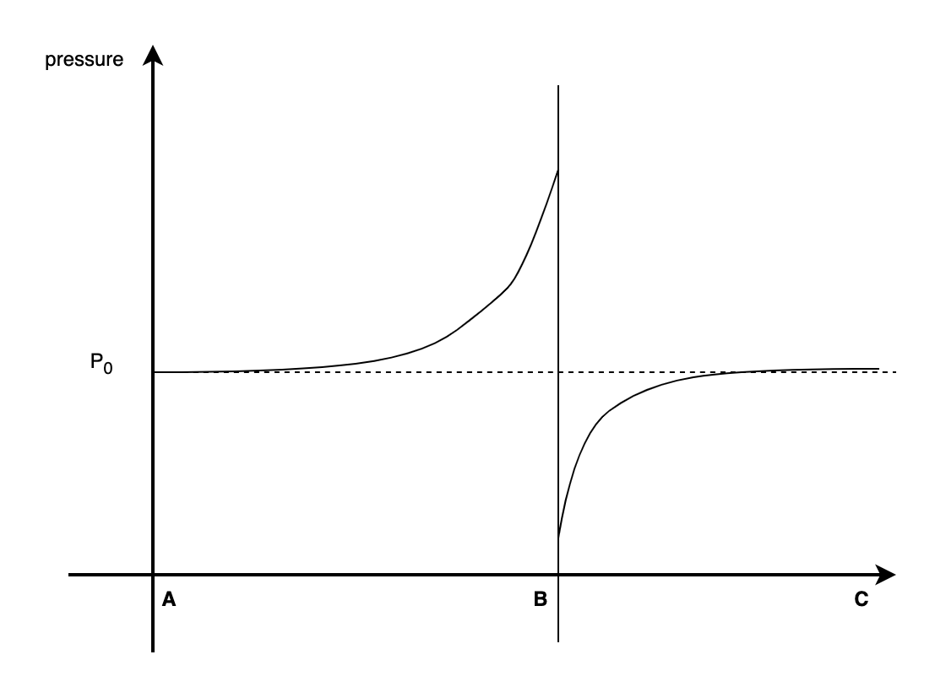
(a) | (b)

Fig 3. Flow around a flat sheet with viscosity. (a) The flow underneath and above the sheet is forced to curve. (b) Pressure distribution along the dotted line (ABC), showing high pressure under the sheet and low pressure above the sheet, which generates more lift.

To encourage the flow to follow the sheet we make the leading edge thicker and rounded, hence forming an airfoil section. Additional aids include the introduction of a slot at the leading edge to guide the flow. We also take care to avoid any interruption to the flow on the top edge by mounting the engines and any other paraphernalia below the wing, where it cannot affect the flow too much. Nevertheless, there is always a danger that the flow can suddenly switch from that illustrated in fig. 3 to that in fig. 2, in which case the lift would be halved and the aircraft falls out of the sky. This is called a stall and can be caused by flying too slowly at too high an angle or by the formation of ice on the leading edge of the wing. There have been many deaths over the years due to this effect.

While this picture is superficially attractive, there are problems as soon as we try to make it more precise. If air is blown at right angles (90º) on to a sheet some of the air comes to rest at what is known as the stagnation point. At this point, the maximum pressure (force per unit area) is 0.5ρv². Now suppose that the sheet is tilted so that none of the air comes to rest. You would expect the force per unit area to reduce dramatically for small angles and there would be insufficient force to lift an aeroplane off the ground.

So far we have ignored the trailing edge, but in many ways this is the most important part of the wing. However, to explain this requires some considerably more complicated fluid mechanics. It is natural to imagine fluid flow as an example of other flows, such as heat flow or current flow, and, indeed, in an incompressible non-viscous fluid, the equations are similar, particularly in two dimensions. If the fluid is incompressible, div(v) = 0 and the condition for zero viscosity is curl(v) = 0. This means that, like the electrostatic potential, we can define a single-valued potential φ such that v = –grad(φ) and ∇²φ = 0. If we solve ∇²φ = 0 with the boundary condition v = v_{o} in the x direction at boundaries at large distances for the sheet of fig. 2 we obtain the streamlines shown in fig. 4. There is clearly a major problem. Although the pressure below the sheet is as shown in fig. 2 and the flow follows the sheet, the flow is exactly symmetric, resulting in no lift and no drag. This is, in fact, inevitable from the boundary conditions, which effectively ensure that the there is no momentum change in any direction (Newton’s second law). The pressure argument is valid, but it can be seen that above the trailing edge there is an inverse pressure gradient that reduces the lift to zero.

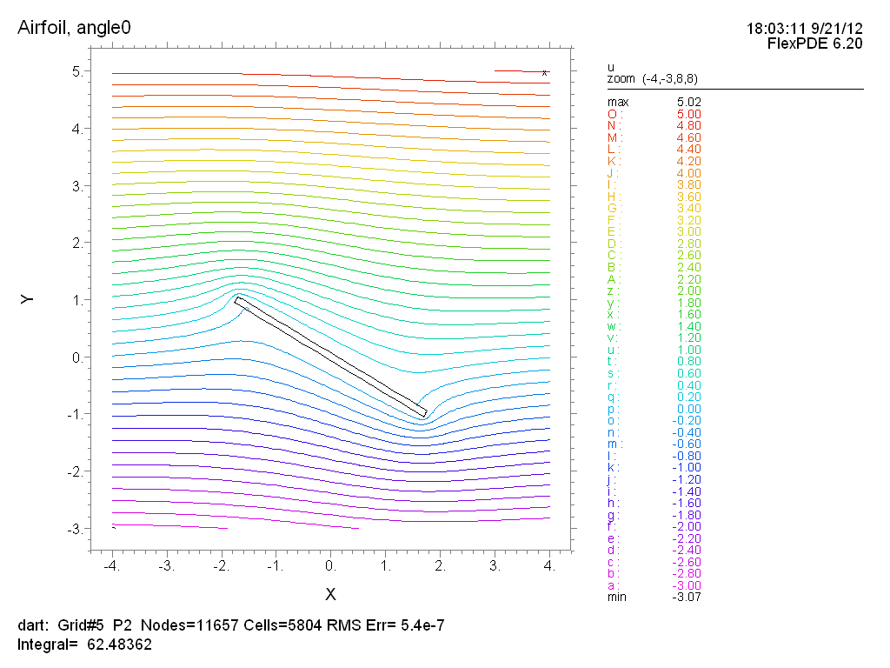
Fig. 4. Potential flow round a sheet. Lift and drag are zero. OUP: I DON'T KNOW WHERE THESE IMAGES COME FROM

To progress this analysis, it is useful to consider a system with an analytic solution, and its magnetic analogue. This is a cylinder transverse to the flow. The magnetic analogue is a superconducting cylinder, or perfect diamagnet, transverse to a uniform magnetic field so that all flux is excluded. In this case the only relevant solutions are a uniform field, r cosθ and a dipole field corresponding to the magnetic moment of the cylinder, varying as (1/r) cosθ. Again, the lift and drag are zero, as are the force on a diamagnet in a uniform field. However, if we use the vector potential, or stream function, in which v = curlψ another solution is possible, (corresponding to a current down the cylinder in the normal direction). This is a vortex solution ψ = ln(r). For this v_{r} = 0 and v_{θ} = 1/r. This is a free vortex with a singularity at the centre, like a tornado, but if we are only interested in the field outside the cylinder the singularity is not a problem. The solution is then a ‘bound’ vortex, bound to the cylinder. We write the potential as c/2π ln(r) so that v_{r} = 1/2πr and ∫v.dr is c (the ‘circulation’), for any contour which encloses the cylinder only once. (In the magnetic case it is the current in the wire. ∫Bdl = μ_{o}I. Here the forces are in the opposite direction as a high field implies a high pressure).

Rotating Sails and the Magnus Effect on a Rotating Cylinder

The reason for analysing the cylinder in some detail is that the results apply equally to other shapes. In the magnetic analogy the force on the wire is independent of the shape of the wire, F = B_{o}I.

The stream function for a cylinder of radius a is;

v_{o}r sin(θ)+(a²/r) sin(θ)+(c/2π) ln(r)

From which all the velocities and forces can be calculated. Fig. 5 shows the streamlines, assuming there is circulation.
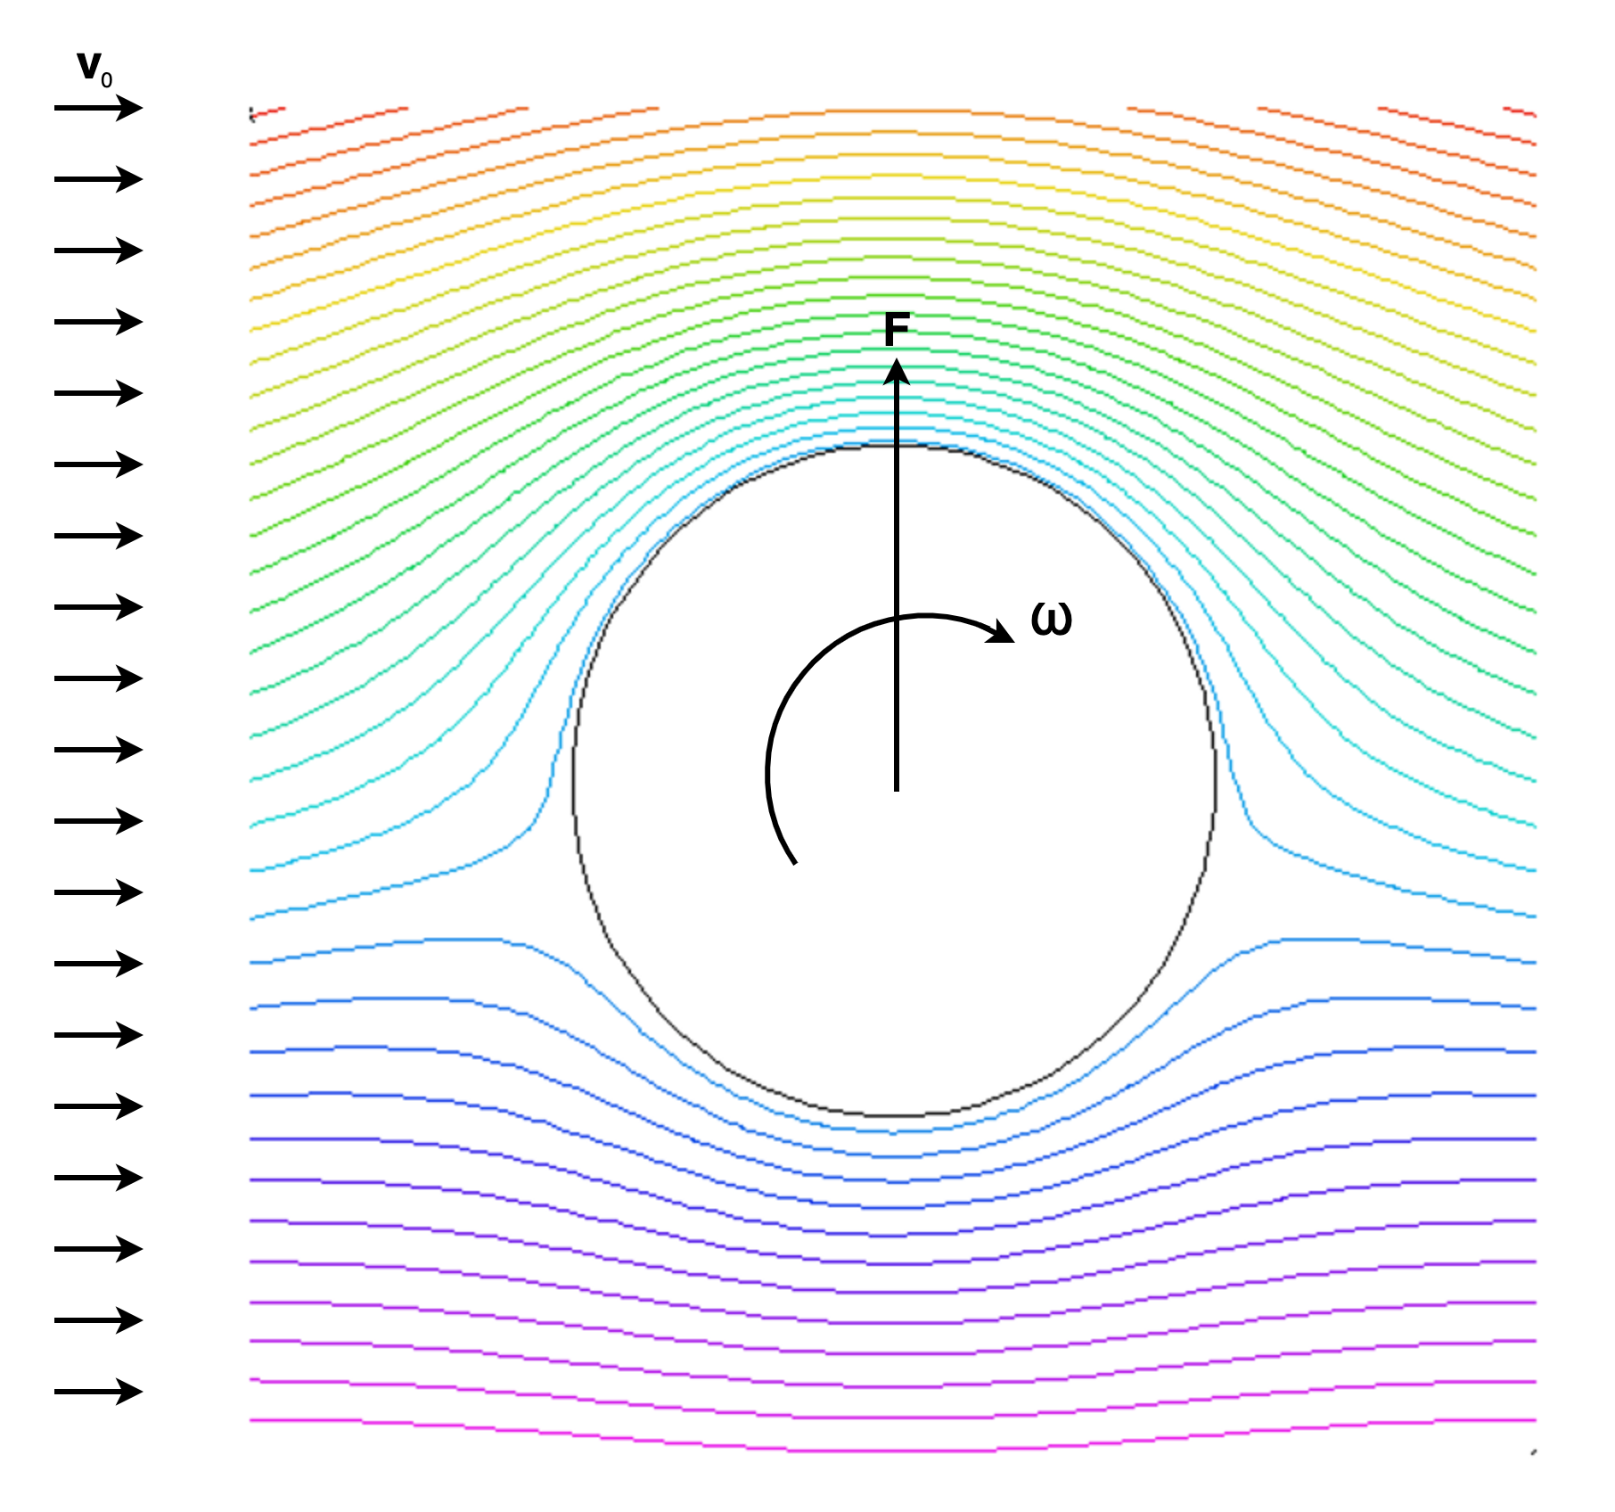
Fig. 5. Flow round a rotating cylinder. OUP: I DON'T KNOW WHERE THESE IMAGES COME FROM

The result is that the lift is F = ρv_{o}c and the drag is zero. This is the Magnus effect. If we rotate the cylinder, then the velocity on the surface is ωa and the lift force per unit length is.2πa²ωρv_{o}. This is why spinning balls swerve, and the effect can also be used to drive boats with rotating cylinders instead of sails, although this is not very efficient.

If we have a shaped airfoil, other than a cylinder, we need to add quadrupole and other terms to the potential to describe the field near the airfoil. However, these all decay more rapidly than the dipole field. The force on the airfoil can be found by integrating the pressure and momentum flux well away from the airfoil and at a point where these higher terms have disappeared, so we can conclude that, whatever the shape, the lift is always cv_{o}. (This is also the reason why the force on a wire carrying a current in a uniform magnetic field is independent of the shape of the wire). Also, the drag is zero, whatever the shape of the object (the so-called Laplace paradox).

Fig. 6(a) shows the streamlines for an airfoil with zero circulation (zero viscosity) and with the flow at an angle of 8° to the bottom surface. This will be the flow on starting the wing since the initial circulation is zero. Lord Kelvin showed that if the circulation is zero at any time, then it remains zero at later times. However, if we expand the diagram at the trailing edge fig. 6(b) we see a very curved set of streamlines, and in Fig. 6(c), where the velocity round the wing is plotted, we see a sharp discontinuity in velocity at the trailing edge.

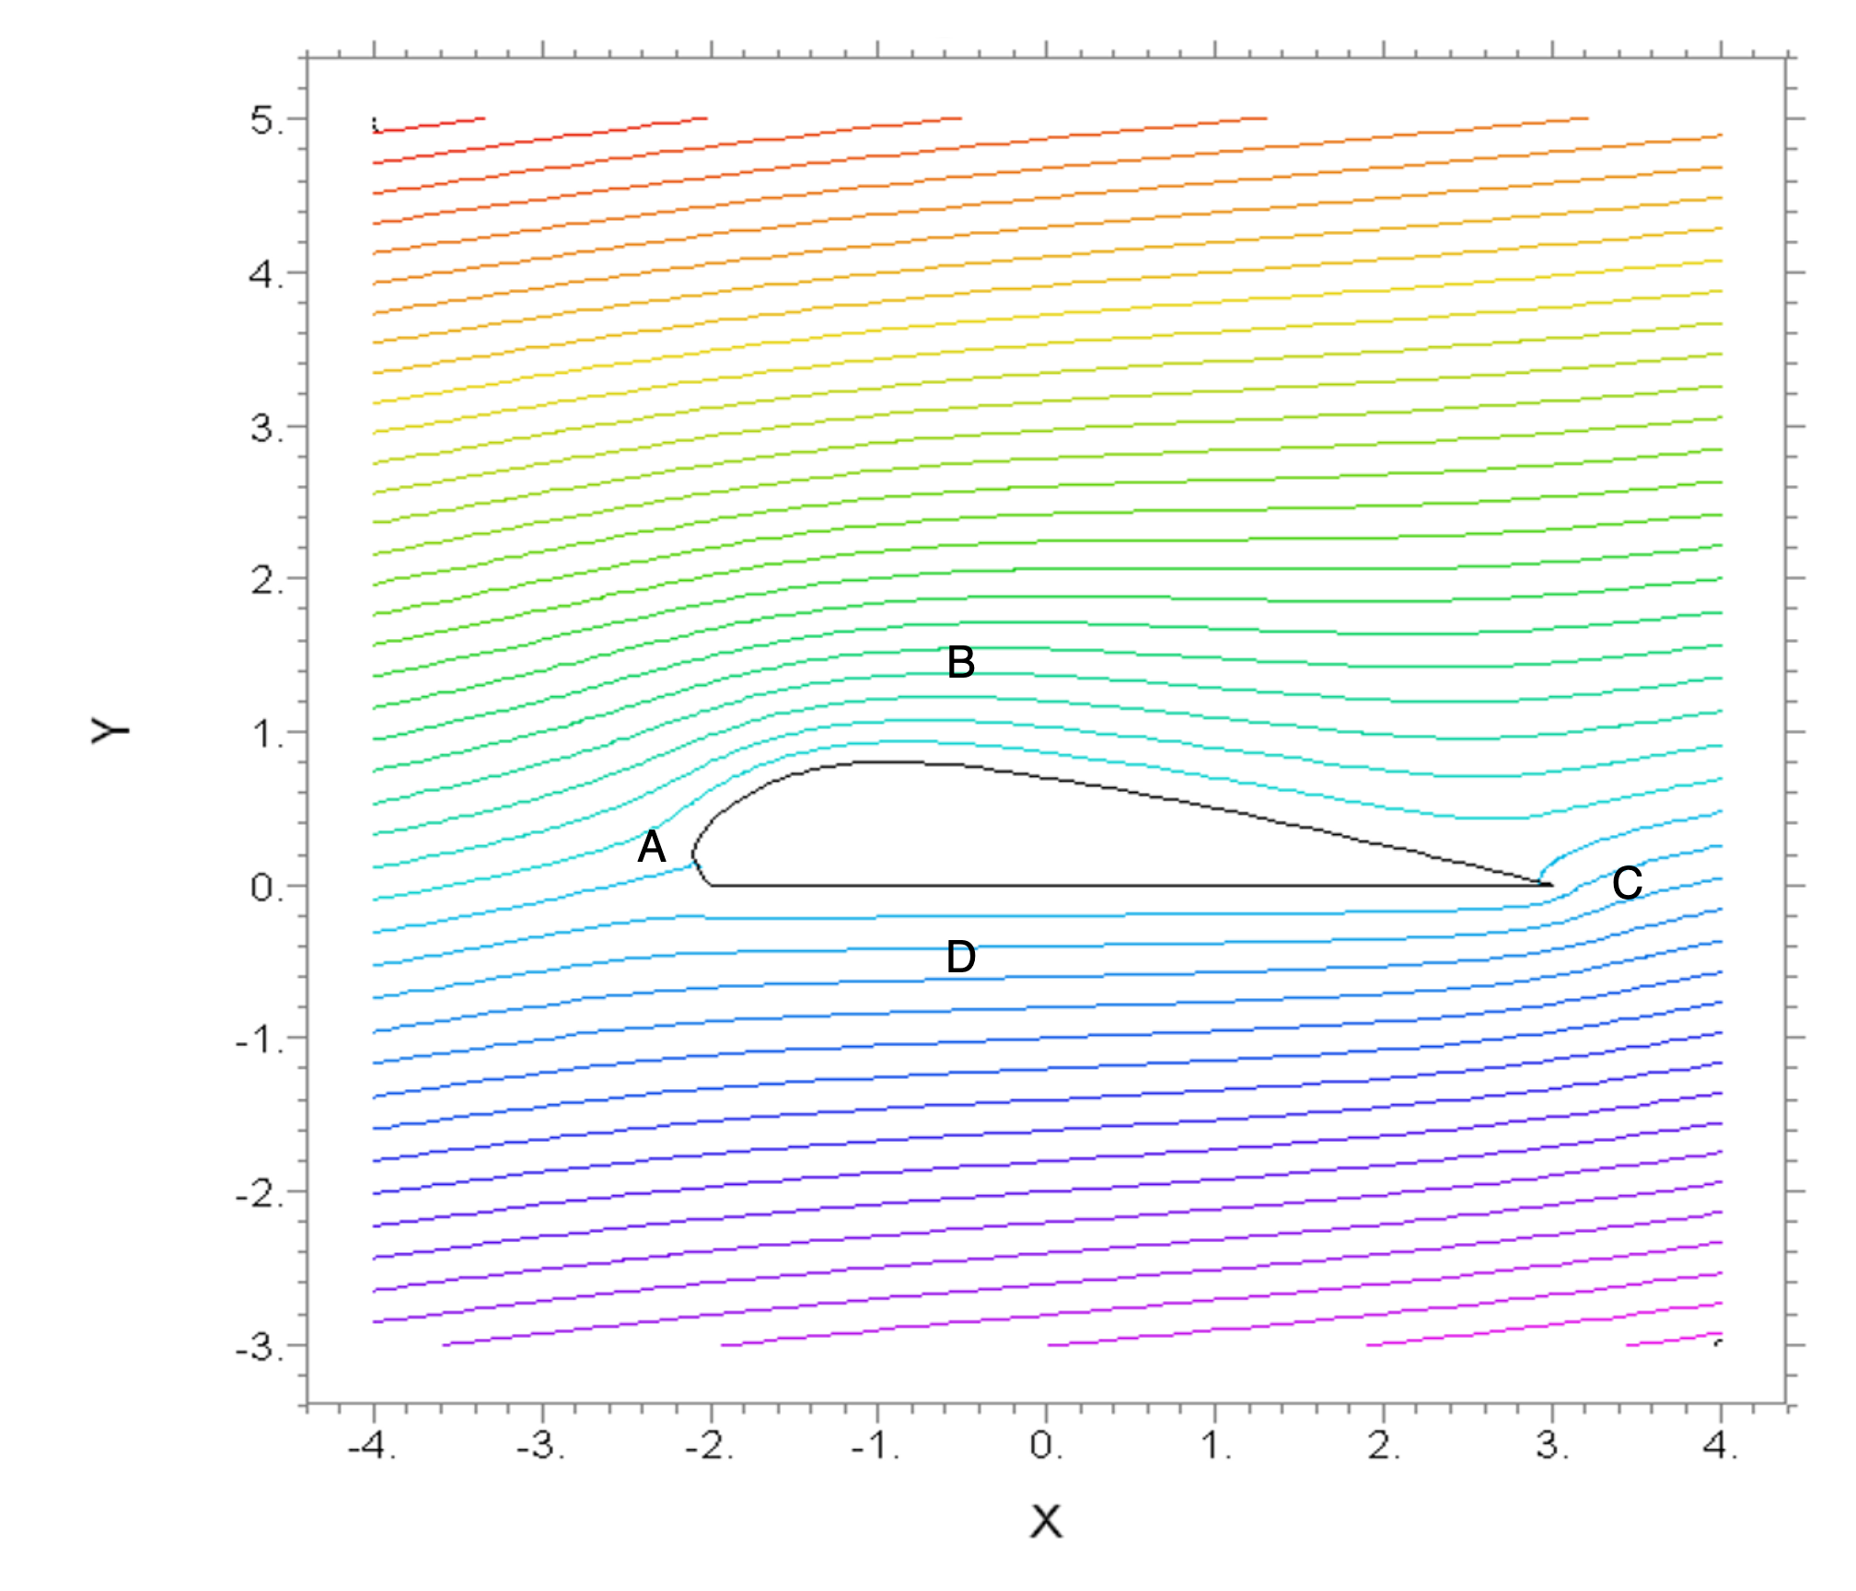 | 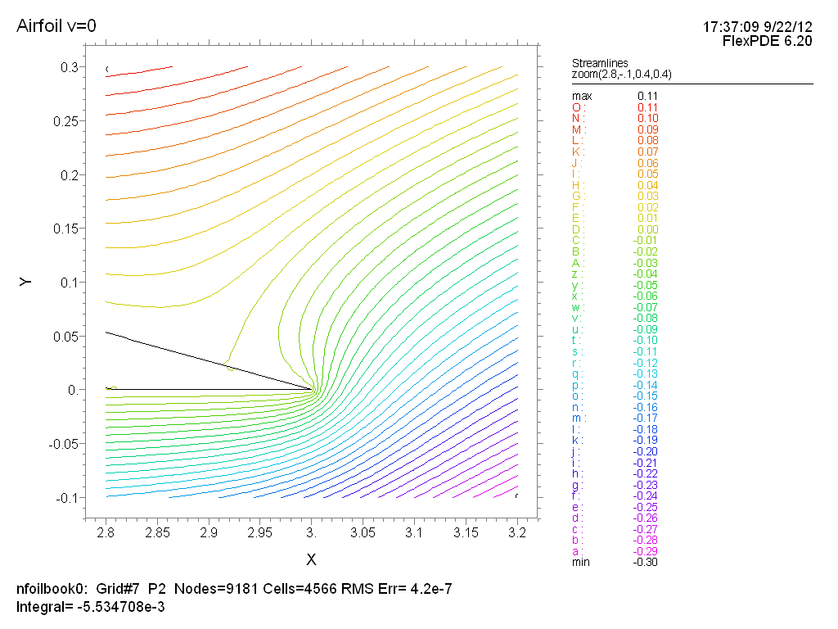
(a) | (b)

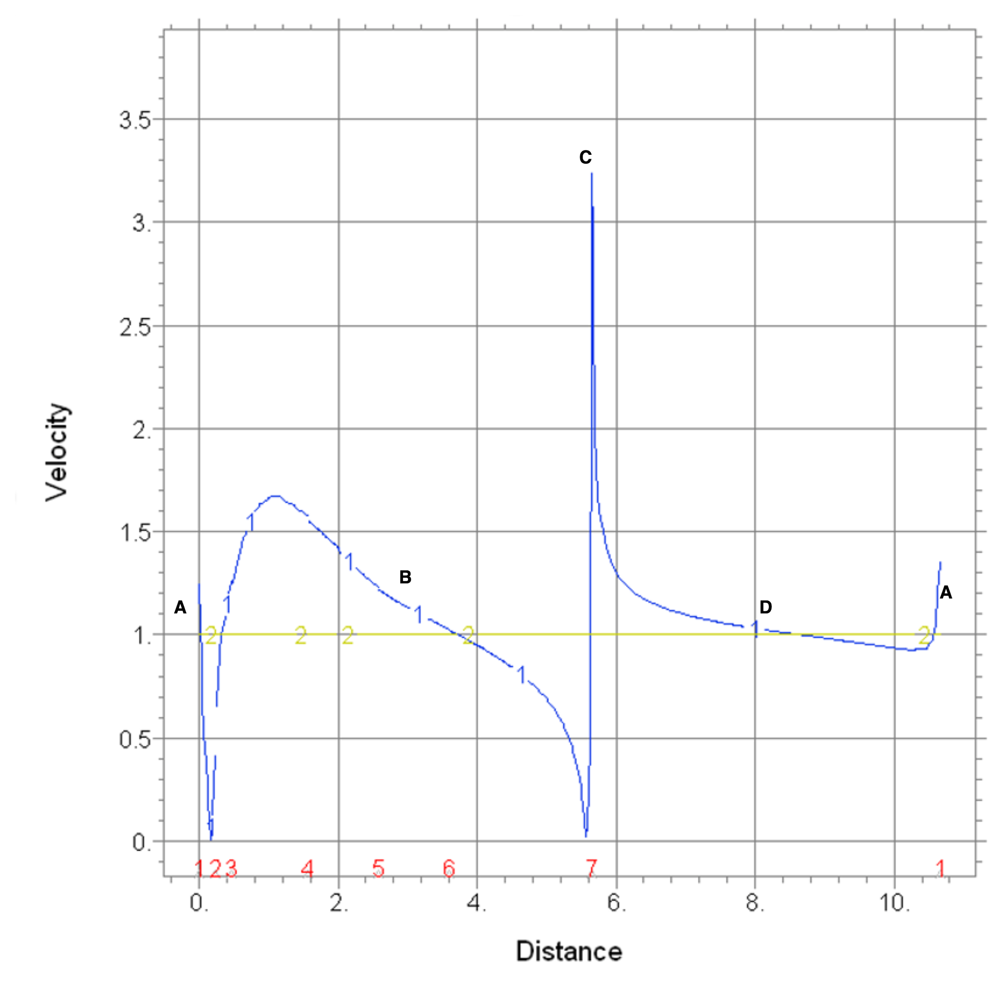
(c)

Fig. 6. The flow around an airfoil with zero circulation (a), overview of the flow. (b) Close-up of the trailing edge noting that the flow is unrealistic. (c) Velocity around the airfoil’s surface from A to D and back to A. OUP: I DON'T KNOW WHERE THESE IMAGES COME FROM

This means that there are two flows of very different velocity meeting at this point, one that has come under the wing, and the other over the wing. This is unstable if there is a finite viscosity, and the two flows interact to generate a local vortex. This is swept away downstream but, to keep the overall circulation zero (at least until the vortex disappears), the flow round the wing generates an opposite circulation. The steady state is reached when the bound vortex on the wing is strong enough to make the discontinuity in velocity at the trailing edge disappear (the Kutta condition), as shown in fig. 7, and the flow of the trailing edge then becomes smooth.

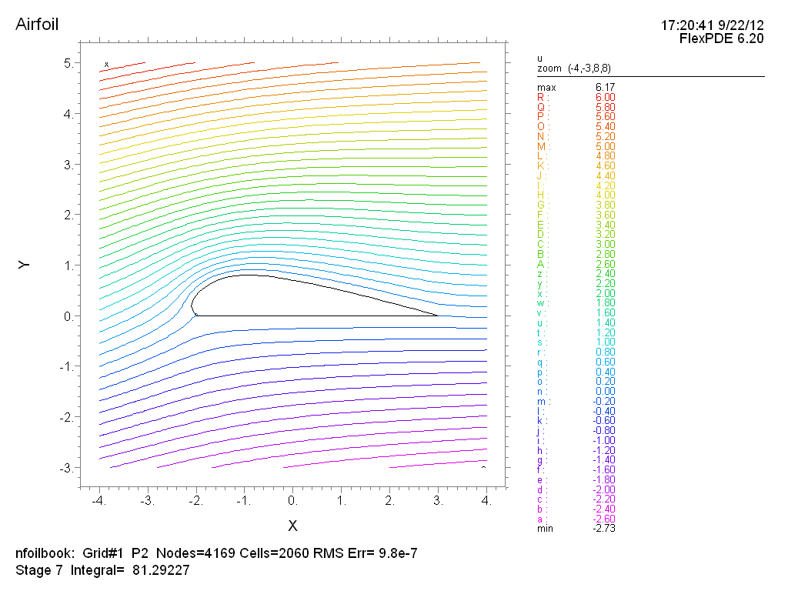 | 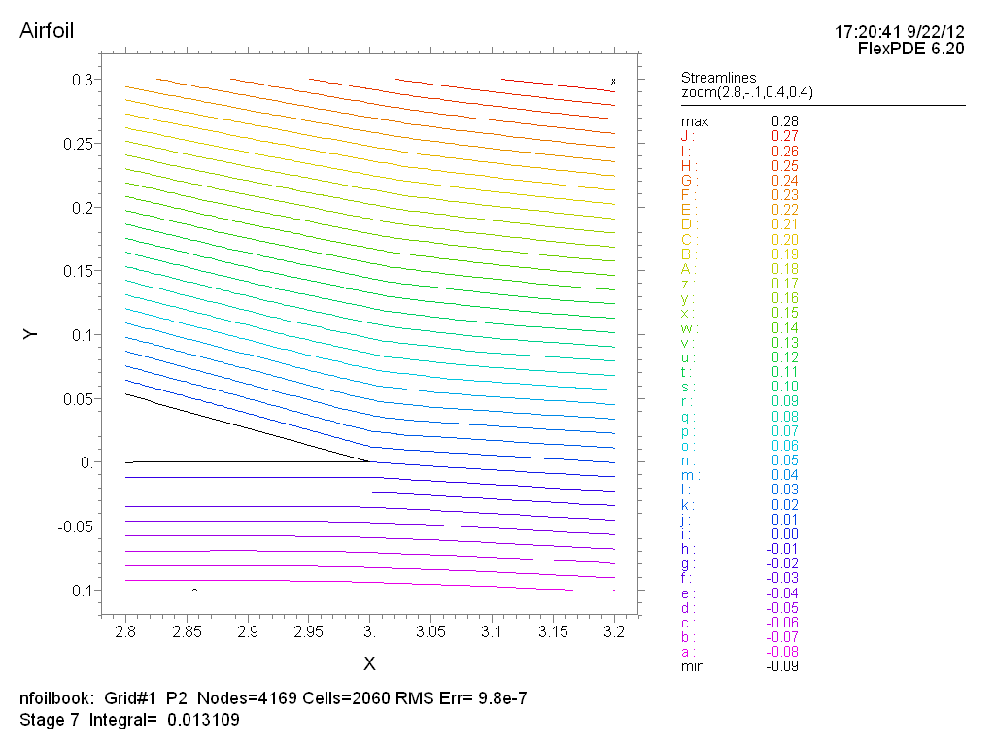
(a) | (b)

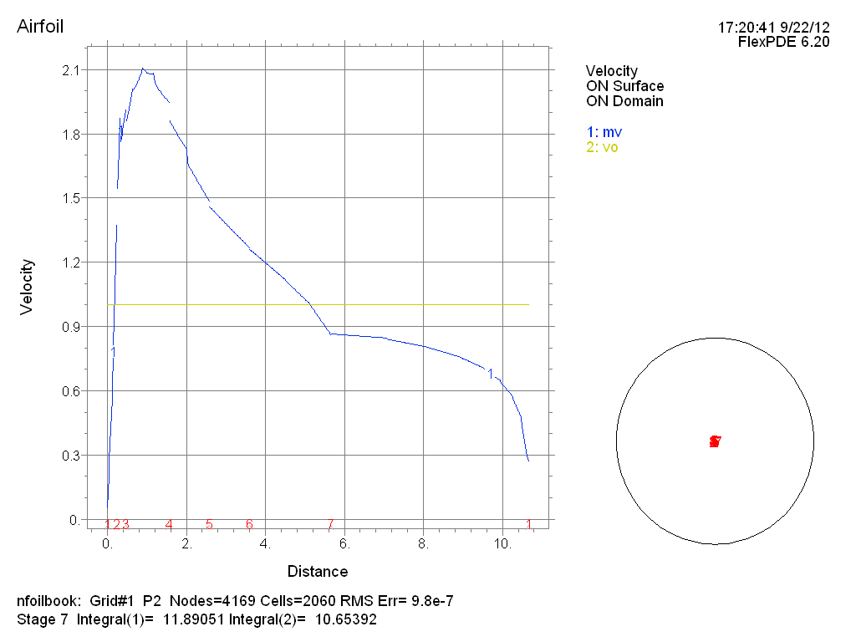

(c)

Fig. 7. The flow around an airfoil with circulation, c = 4.8 (a), overview of the flow. (b) Close-up of the trailing edge noting that the discontinuity has disappeared. (c) Velocity around the airfoil’s surface. OUP: I DON'T KNOW WHERE THESE IMAGES COME FROM

If v_{o} = 1 and ρ = 1, this occurs with c = 4.8. This can be made meaningful if we compare the lift force with that experienced by orienting the wing at right angles to the flow. This is of order ρv² times the width if all the momentum is dissipated, and half this if we can apply Bernoulli’s equation. Let us therefore normalise the lift force by dividing it by 0.25 given that the width of this airfoil is 5 units. This gives a coefficient of lift of 1.8. In other words, the lift force with the wing at 8° to the flow is considerably larger than the force on the wing if it were to be set at 90° to the flow. This very surprising result is due entirely to the circulation set up around the wing by the sharp trailing edge. The conventional explanation in terms of the Bernoulli effect is correct in the sense that the velocity above the wing is much greater than that below, so the pressure is less. However, this velocity is due to the large velocity of the vortex round the wing generated by the trailing edge, not the shape of the airfoil itself.

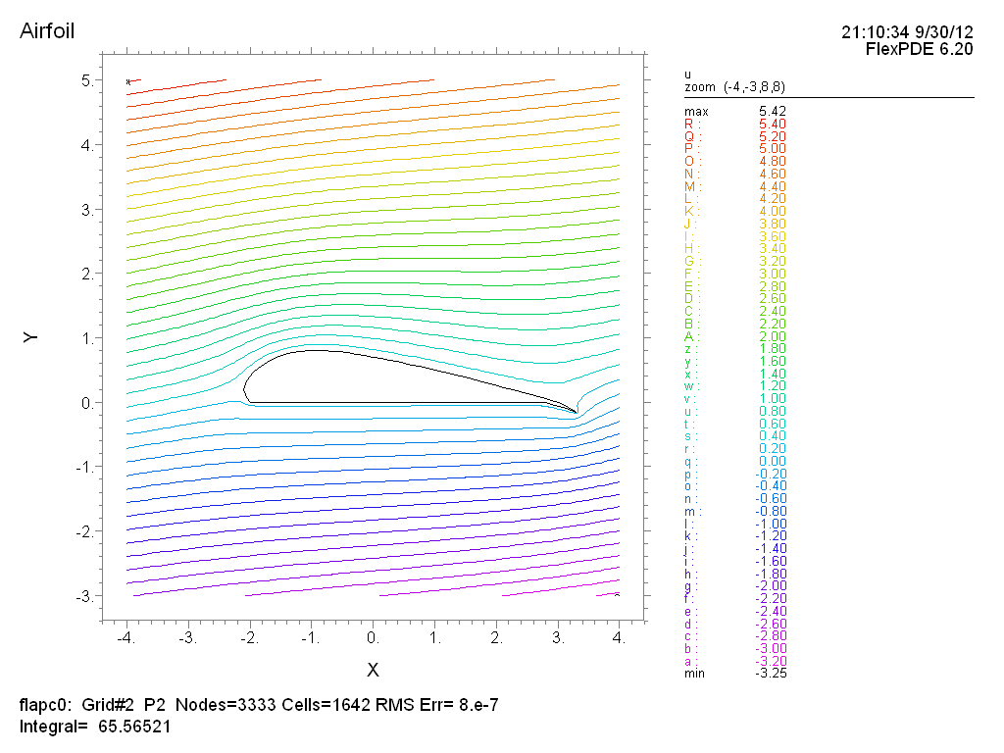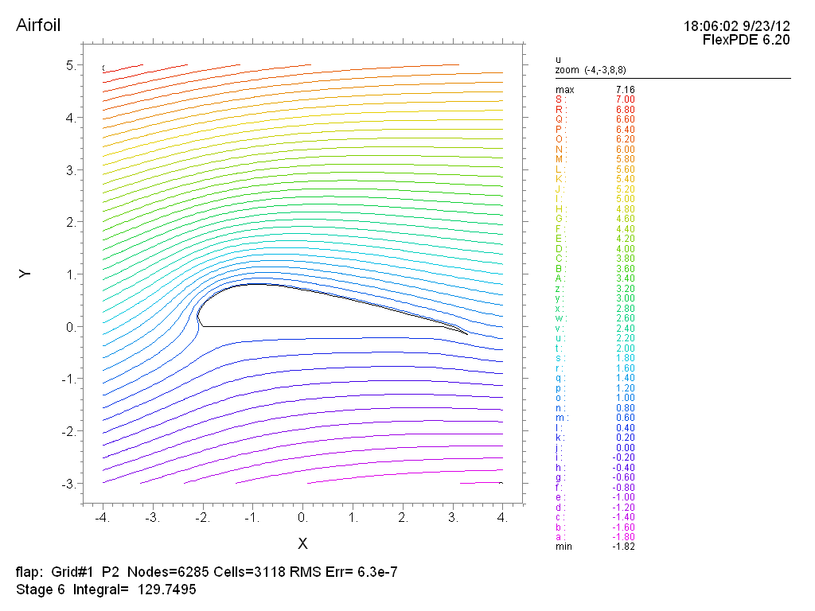
(a) (b)

Fig. 8. Flow around a wing with a flap with (a), c =0 and (b) c = 6.1. OUP: I DON'T KNOW WHERE THESE IMAGES COME FROM

This can be illustrated by adding ‘wing flaps’ at the trailing edge, which all air passengers have seen being extended as a plane comes into land. A small extra downward flap has been added to the wing in fig. 8. This means that, to avoid the discontinuity in velocity, the circulation rises to 6.1 and the normalised lift to 2.4. This small modification increases the lift by 50%, which is much too large to be explained by the extra airflow directed downwards by the small flap. The effect is due to the extra vortex flow round the wing triggered by the flap.

So far, the equations have been expressed in arbitrary units. As a result, we now need to see if they apply to the real world. The take-off weight of a fully loaded Boeing 747 is approximately 400,000 kg or 4 MN. The take-off speed is quoted as 180 knots. It is strange, but true, that in the twenty first century a high-tech company like Boeing is still using a unit of speed based on releasing a rope from the back of the aircraft and counting the number of equally-spaced knots as they pass! We will write this as 92 m/s. The wing area A is 525 m² and the density of air 1.14 kg/m^{3 .}

With these numbers, 0.5ρv² A = 2.6 MN, which is in the right ballpark. We can certainly get a 747 off the ground when we add the effect of circulation.

This treatment leaves out a lot of important effects, it predicts zero drag, in particular, which is obviously wrong, although it is an indication of why the lift to drag ratio of a wing is so much lower than any simple picture suggests. More detailed accounts for physicists can be found in text books that show how our understanding falls well short of describing real fluid mechanics. This is a very complex subject. According to one eminent physicist: ‘there are only two major unsolved problems in physics; one is turbulence, the other the origin of the universe. However, we are making some progress on the origin of the universe’

The ground effect

There can be a significant increase in lift when an airplane is very close to the ground. The Russians built a few experimental planes to take advantage of this effect. They could fly over very flat terrain, such as lakes, carrying much heavier loads than they could lift into to the sky. An earlier application was by Spitfire pilots during the second world war. They found they could tip over flying bombs so that they fell harmlessly into the countryside by bringing their wings up below the wings of the flying bomb, without touching them.

The ground effect can be modeled by putting an image airfoil under the original so that the flow is parallel to the x axis mid-way between them. Fig. 9 shows that this gives a larger discontinuity in velocity at the trailing edge due to due to the downdraught from the other airfoil. This requires the circulation to be increased to 6, a 50% increase, implying a similar increase in lift. However, there is another effect which counters this, which is the attraction between the images. (In the magnetic case it is a repulsion, as in a magnet floating above a superconductor.) The reason for this can be seen from fig. 5. If we have two cylinders, one above the other, rotating in opposite directions the circulation from the lower cylinder opposes the velocity applied to the upper cylinder, so decreasing the lift. In this case there is an attraction, even with no circulation. It turns out that, for the airfoil shown, this effect is larger than the circulation effect and the lift is decreased slightly by the ground effect, so it appears that potential theory cannot explain the ground effect. A dangerous example of the image attraction is if a car or bicycle is overtaking a heavy lorry. The image attraction can suck the car or bicycle into the lorry with fatal results.

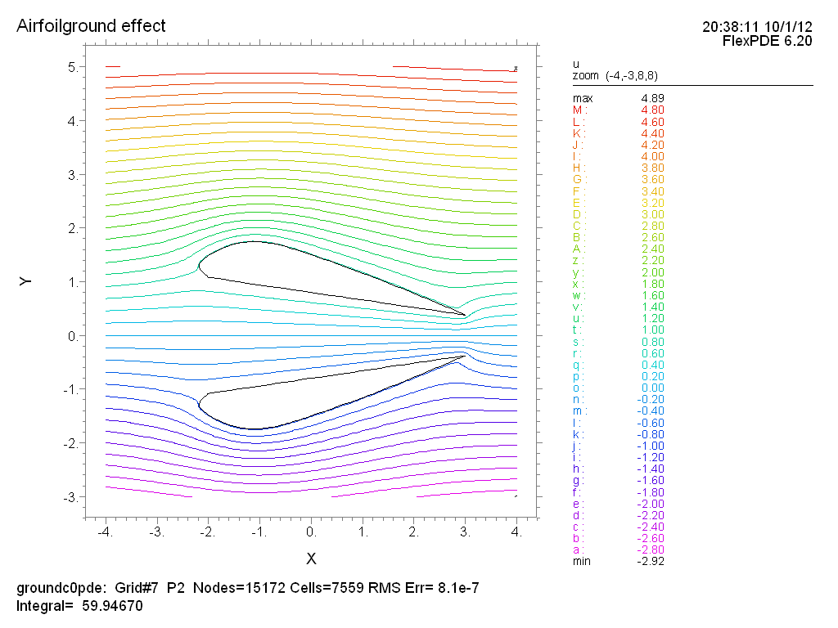
Fig. 9. Streamlines in the ground effect. OUP: I DON'T KNOW WHERE THESE IMAGES COME FROM

Sails

Sometimes sails are likened to airfoils, although this is generally a very bad analogy since the sail is a uniformly thin sheet, like a paper dart, but curved. We’ve seen in Fig. 3 how we can generate a force from air flowing around a thin sheet. Let’s now develop that a bit further.

In Fig. 10 a boat is sailing into the wind. The force of the wind would tend to push the boat backwards were it not for the keel, which counteracts the normal component of the force leaving only the forward component. The “apparent wind” which is the velocity of the wind relative to the boat acts on the sail to provide a force in the direction of travel.

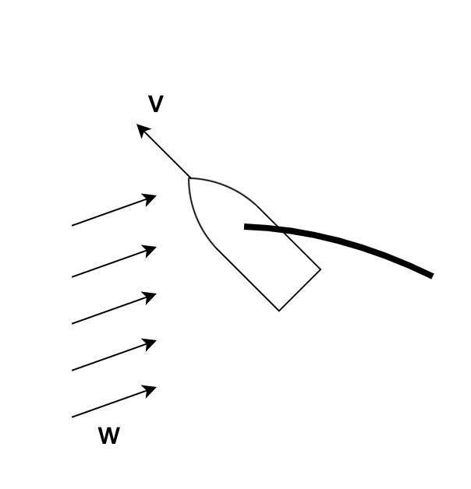 | 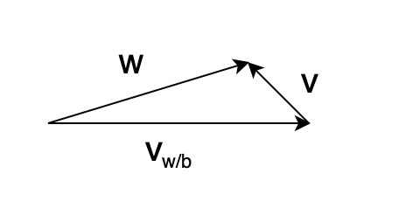
(a) | (b)

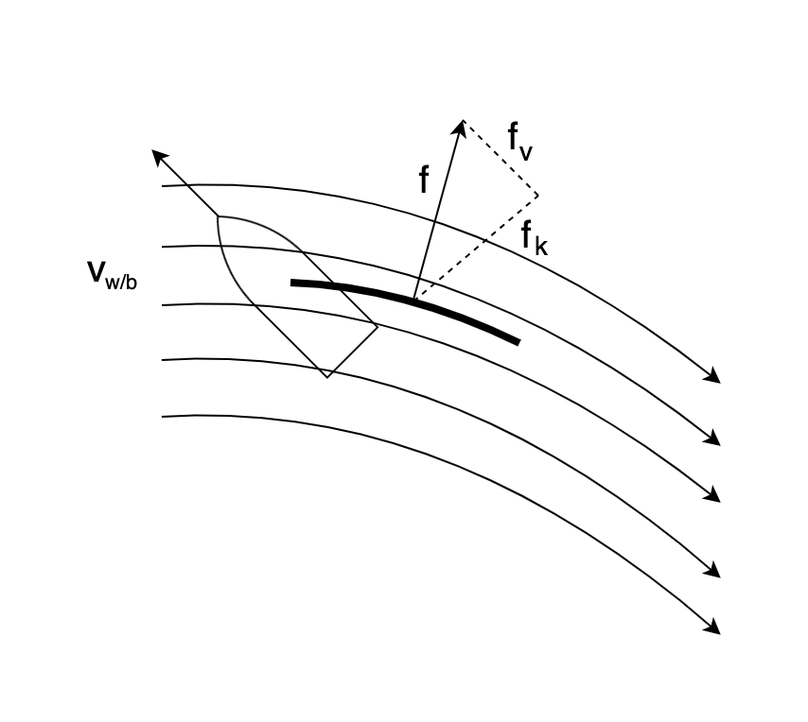
(c)

Fig. 10. A boat sailing into the wind. (a) a boat moving with velocity v against a wind with velocity w. (b) The velocity of the wind relative to the boat v_{w/b} is obtained by vector subtraction. (c) the wind moving around the curved sail generates a force f normal to the sail with components f_{v} in the direction of the boat velocity and f_{k,} which is a force resisted by the keel.

We can also see why a boat can move faster than the wind driving it. In Fig. 11, the boat is moving downwind (not exactly downwind, we’ll see later that you cannot go faster than the wind if it is directly behind you). The apparent wind again generates a force on the sail in the direction of travel.

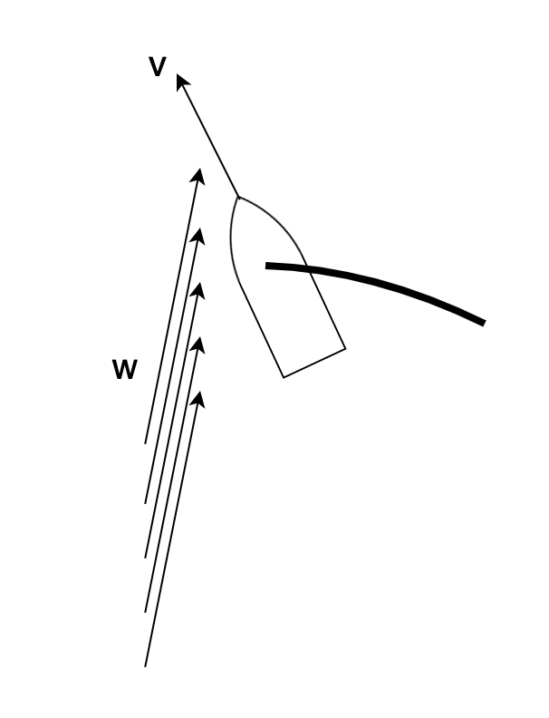 | 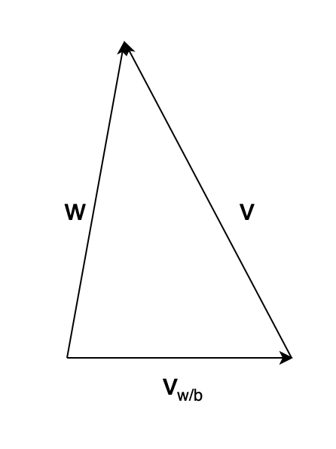
(a) | (b)

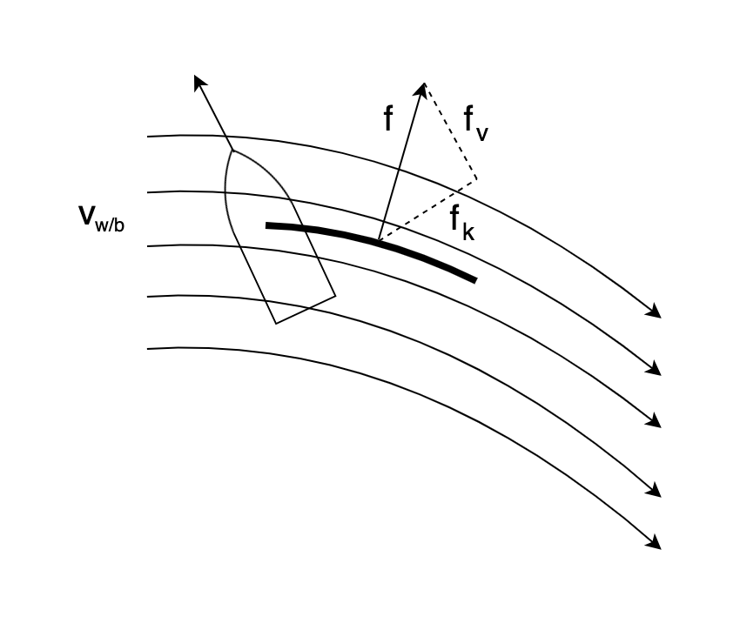
(c)

Fig 11. A boat sailing downwind faster than the wind (a) the boat moves with velocity v with a wind with velocity w. (b) The velocity of the wind relative to the boat v_{w/b} is obtained by vector subtraction. (c) Even though the boat is moving faster than the wind, there is still a force in the direction of the boat.

If the wind is directly behind the boat, then the boat cannot go faster than the wind or it will be going against the apparent wind. However, if the boat travels at an angle, there is still a driving force, so v can be greater than w. The wind seen by the sail is the vector sum of w and –v which is v_{w/b} (velocity of wind relative to the boat). As v increases, this swings round until the apparent wind is a head wind so the driving force decreases, and the jib must be pulled in. Whether v can exceed w depends on the efficiency of the sail and the drag, but in a fast boat it is possible. A skater uses a similar principle by pushing sideways with the skate at a small angle, so that since it cannot move sideways the forward motion must be much faster than the motion of the leg pushing the skate.

However, like a wing, the actual force on the sail depends on the circulation round it generated by the trailing edge. Figure 12 shows a typical sail with the leading edge parallel to the wind and zero circulation. There is a large discontinuity at the trailing edge similar to the effect we saw in Fig 6. As before by including circulation this effect can be minimised. The force experienced by the sail is large, even when it appears to be almost parallel to the wind. It turns out that this force is even bigger than if the sail were perpendicular to the wind as for example a spinnaker.

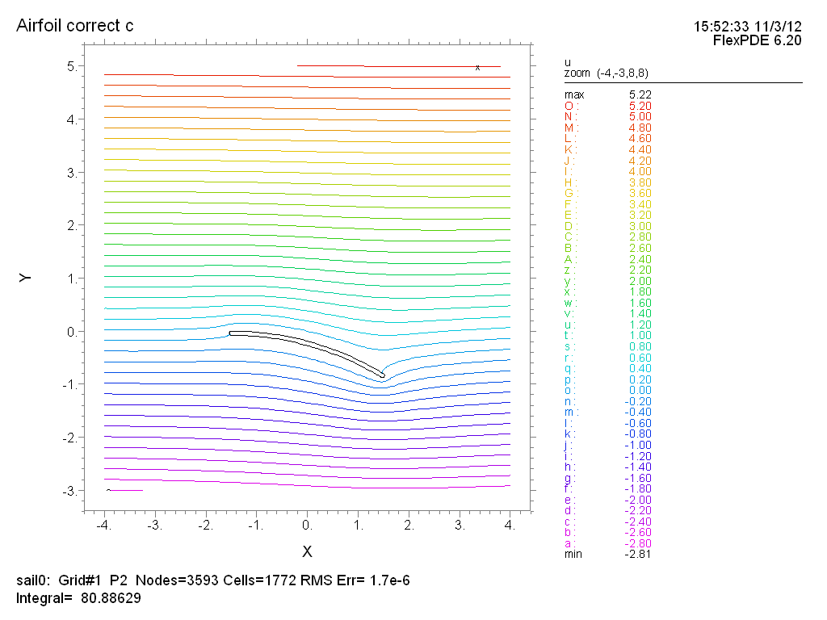
Fig. 12. Potential flow round a sail. OUP: I DON'T KNOW WHERE THESE IMAGES COME FROM

Reference

- How do Wings Work? Holger Babinsky, IoP Physics Education 38 (6), 297, 2003.

